**Project Documentation**

**COOK BOOK: YOUR VIRTUAL KITCHEN ASSISTANT**

**1. Introduction**

**Project Title:** COOK BOOK: YOUR VIRTUAL KITCHEN ASSISTANT

**Team ID:** [NM2025TMID42731]

**Team Leader:** [GAYATHRI G A & [gayathrigayathri32315@gmail.com](mailto:gayathrigayathri32315@gmail.com)]

**Team Members:**

[KEERTHIKA P & [keerthika2007anadhi@gmail.com](mailto:keerthika2007anadhi@gmail.com)]

[MADHUMITHA M & [velluvellu395@gmail.com](mailto:velluvellu395@gmail.com)]

[KOKILA M & [kokila04murugan@gmail.com](mailto:kokila04murugan@gmail.com)]

**2. Project Overview**

**Purpose:**

"Cook Book: Your Virtual Kitchen Assistant" is designed to serve as a smart, accessible, and personalized culinary companion for users of all skill levels. Its primary goal is to simplify the cooking experience by providing:

1. **Easy Access to Recipes**  
   A curated and searchable collection of recipes for all tastes, dietary needs, and occasions, organized for quick reference.
2. **Step-by-Step Cooking Guidance**  
   Clear, interactive instructions that guide users through the cooking process with tips, timers, and visual aids.
3. **Smart Kitchen Support**  
   Features like voice command, ingredient substitution suggestions, portion scaling, and real-time cooking help make it a dynamic assistant in the kitchen.
4. **Meal Planning & Grocery Management**  
   Tools for planning weekly meals, generating shopping lists, and managing pantry inventory to reduce waste and save time.
5. **Personalization & Learning**  
   Adapts to user preferences, dietary restrictions, and cooking habits to offer tailored suggestions and skill development.

**Features:**

**Features of *Cook Book: Your Virtual Kitchen Assistant***

**1. Extensive Recipe Library**

* Thousands of recipes from global cuisines
* Searchable by ingredients, cuisine, cooking time, difficulty, or dietary needs (e.g., vegan, gluten-free)

**2. Step-by-Step Interactive Cooking Mode**

* Voice-guided instructions
* Visuals and videos for techniques and preparation
* Timers built into each step

**3. Smart Grocery List Generator**

* Automatically creates shopping lists from selected recipes
* Syncs with pantry inventory
* Allows manual additions and categorization by store section

**4. Meal Planning Tool**

* Weekly and monthly meal planners
* Customizable plans for individuals, couples, or families
* Suggests meals based on leftovers or pantry items

**5. AI-Powered Recommendations**

* Personalized recipe suggestions based on cooking history and preferences
* Substitution suggestions for missing ingredients or allergies
* Adaptive learning for improved future suggestions

**6. Voice Assistant Integration**

* Works with smart speakers (e.g., Alexa, Google Assistant)
* Hands-free cooking support
* Voice-controlled timers, measurements, and steps

**7. Nutrition & Dietary Tracking**

* Calorie and macronutrient info per recipe
* Filter recipes by health goals (e.g., low-carb, high-protein)
* Integration with fitness apps

**8. Cooking Skill Builder**

* Tutorials for basic to advanced techniques
* Quizzes and practice challenges
* Tracks progress and achievements

**9. Cloud Sync & Cross-Device Access**

* Save recipes, plans, and grocery lists
* Sync across mobile, tablet, and desktop
* Offline access for saved recipes

**10. Community Features**

* User ratings, comments, and photo uploads
* Share custom recipes with friends or public
* Participate in themed cooking challenges

**3. Architecture**

## ****Architecture of**** Cook Book: Your Virtual Kitchen Assistant

### 1. ****Client-Side (Frontend)****

Interfaces where users interact with the application (Mobile, Web, Smart Devices).

**Platforms:**

* Mobile App (iOS/Android – built using Flutter/React Native)
* Web App (React/Vue.js)
* Voice Assistants (Alexa Skills, Google Assistant Actions)

#### UI/UX Components:

* Recipe Browser
* Interactive Cooking Mode
* Meal Planner Dashboard
* Smart Grocery List Interface
* Voice Interaction Controls

### 2. ****Server-Side (Backend)****

Handles business logic, database operations, personalization, and AI integrations.

#### Core Services:

* **Recipe Management Service**: CRUD operations for recipes (add/edit/delete/search)
* **Meal Planning Service**: Weekly/monthly planner, saved plans
* **Grocery List Service**: Generates and syncs lists from recipes
* **User Profile Service**: Preferences, dietary needs, saved history

#### Authentication & User Management:

* OAuth2 / JWT-based Authentication (Google, Email, Social Logins)
* Role-based access (e.g., admin, regular user)

3. **Databases**

Storage for structured and unstructured data.

#### Types of Databases:

* **Relational DB** (PostgreSQL / MySQL):
  + User profiles, meal plans, preferences
* **NoSQL DB** (MongoDB / Firebase):
  + Recipes, cooking steps, community content
* **Search Engine** (Elasticsearch / Algolia):
  + Fast recipe and ingredient search

### 4. ****AI & Recommendation Engine****

Personalized and dynamic support powered by machine learning and NLP.

#### Features:

* Recipe Recommendations (based on history, preferences)
* Ingredient Substitutions & Smart Suggestions
* Pantry-Based Recipe Suggestions
* Calorie & Nutrition Estimation (using food databases like USDA)

#### Tools:

* NLP: To understand user voice/text input
* ML: For personalized recommendations
* Integration: OpenAI, TensorFlow, or custom ML models

### 5. ****Integration Layer (APIs & External Services)****

Interfaces with third-party services and external APIs.

#### 🔗 APIs:

* Voice Assistants (Alexa, Google Assistant)
* Grocery APIs (Walmart, Instacart – for auto-list filling)
* Nutrition APIs (Edamam, Spoonacular)
* Calendar APIs (Google Calendar for meal planning)

#### 🧠 AI Integration:

* ChatGPT for conversational support & cooking help
* Custom NLP models for voice/text understanding

### 6. ****Cloud Infrastructure****

Manages deployment, storage, and scalability.

#### ☁️ Cloud Platform:

* AWS / Google Cloud / Azure

#### Services:

* Serverless functions (AWS Lambda / Cloud Functions)
* Cloud Storage (for images, videos, PDFs)
* CI/CD pipeline for deployment (GitHub Actions, Jenkins)

7. **Security Layer**

Ensures data protection, privacy, and secure access.

* Data encryption (at rest and in transit)
* GDPR & HIPAA compliance (for user data)
* Rate limiting & DDoS protection

### 8. ****Analytics & Monitoring****

Tracks usage, performance, and helps in continuous improvement.

* **User Analytics**: Google Analytics, Mixpanel
* **Crash & Error Reporting**: Sentry, Firebase Crashlytics
* **Performance Monitoring**: New Relic, Datadog

### ****Architecture Flow Diagram (Textual)****

User Device (Mobile/Web/Voice)

↓

Frontend UI/UX

↓

API Gateway

↓

┌─────────────────────────────┐

│ Backend Services │

│ ─ Recipe & Meal Management │

│ ─ Grocery List Generator │

│ ─ User Preferences Engine │

└─────────────────────────────┘

↓ ↓

Relational DB NoSQL DB

↓ ↓

Recommendation Engine (ML/NLP)

↓

3rd Party APIs (Voice, Nutrition, Grocery)

**Frontend**: React.js with Tailwind CSS and Material UI

**Backend:** Node.js with Express.js handling APIs and business logic

**Database:** MongoDB for storing user profiles, workouts, and progress logs

**Additional Services**:

JWT Authentication for secure login

Cloud storage for media uploads (profile pictures, progress photos)

**4. Setup Instructions**

**Prerequisites:**

Node.js

MongoDB

Git

React.js

Express.js

Visual Studio Code

**Installation Steps:**

# Clone the repository

git clone <repo-link>

# Install client dependencies

cd client

npm install

# Install server dependencies

cd ../server

npm install

**5. Folder Structure**

FitFlex/

│-- client/ # React frontend

│ ├── components/

│ ├── pages/

│ └── assets/

│

│-- server/ # Node.js backend

│ ├── routes/

│ ├── models/

│ ├── controllers/

│ └── middleware/

**6. Running the Application**

**Frontend:**

cd client

npm start

**Backend:**

cd server

npm start

Access:

**Visit: http://localhost:3000**

**7. API Documentation**

**User:**

POST /api/user/register

POST /api/user/login

**Workouts:**

POST /api/workouts/create

GET /api/workouts/:id

**Diet Plans:**

POST /api/diet/create

GET /api/diet/:id

**Progress Tracking:**

POST /api/progress/log

GET /api/progress/:userId

8. Authentication

JWT-based authentication for user login and registration

Middleware to protect private routes

9. User Interface

Landing Page – overview and signup/login

Dashboard – personalized fitness plan and daily summary

Workout Tracker – track exercises and calories burned

Diet Tracker – log meals and calorie intake

Progress Charts – visualize weight, calories, and goals

Admin Panel – manage users, workouts, and diets

**10. Testing**

Manual testing during development

Tools: Po stman, Chrome Dev Tools, Jest for unit testing

**11. Screenshots or demo link :**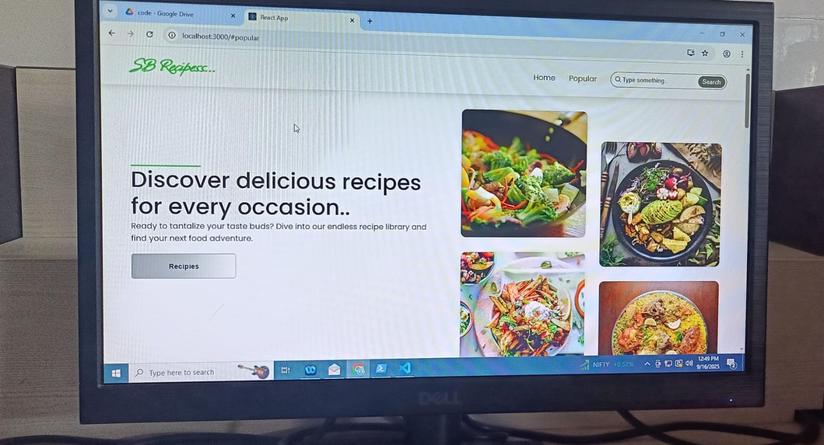

**13. Future Enhancements**

1. **Augmented Reality (AR) Cooking Assistance**

* AR overlays to visually guide users through cutting, measuring, and cooking techniques using smartphone or smart glasses.
* Interactive holographic instructions projected onto kitchen surfaces.

### 2. ****Voice-Activated Cooking Mode 2.0****

* Fully hands-free cooking via voice with real-time feedback (e.g., “You’re overheating the pan”).
* Multi-language voice support for non-English speaking users.
* Integration with custom wake words.

### 3. ****AI-Powered Virtual Chef****

* A customizable AI “chef personality” that teaches, entertains, and interacts with users.
* Can adjust tone for different audiences (e.g., kids, beginners, professionals).

### 4. ****Smart Kitchen Appliance Integration****

* Sync with IoT-enabled kitchen devices (e.g., smart ovens, fridges, scales, blenders).
* Auto-adjust appliance settings based on recipe instructions (e.g., preheat oven automatically).

### 5. ****Real-Time Cooking Collaboration****

* "Cook Together" feature allowing multiple users to follow the same recipe in sync from different locations.
* Integrated video/audio chat for virtual cooking classes or family cooking time.

### 6. ****Dietician and Chef Consultations (Live or AI)****

* In-app access to certified dieticians and chefs for live consultations.